**Creating Custom Business Events in EBS**

**for Integration with OIC**

Prepared for: **FICO**

**By**

**Enterprise Cloud Architect**

**With**

**Oracle Application Integration Team**

Revision History

|  |  |  |  |
| --- | --- | --- | --- |
| Version | Date | Changes | Name |
| 1.0 | 8/01/2019 | Initial Content | Faisal Ansari |
| 1.1 | 8/14/2019 | Added Custom Event Details | Faisal Ansari |
|  |  |  |  |
|  |  |  |  |

# Overview

The purpose of this document is to provide step-by-step approach to creating a custom Business Event in Oracle E-Business Suite (EBS) for the purpose of integrating it in Oracle Integration Cloud (OIC).

The sections below will talk about the following:

1. Create a custom Business Event in EBS
2. Expose the custom Business Event via Integration SOA Gateway (ISG)
3. Use the custom Business Event in Oracle Integration Cloud (OIC).

# Create a Custom Business Event in EBS

The custom Business event created below will function same as a PL/SQL Trigger. The Business event is created on a Purchase Order Business Object. Every time a create, update or delete action happens on this Business Object, it will trigger the custom Business event.

The steps below include creating a custom event in EBS and then deploying a PLSQL procedure and a function EBS database. This requires admin privileges on both EBS UI and Database.

## Create a custom Business Event

To create a custom Business Event you will need to add ***Workflow Administration Responsibility*** to your user.

* Log into EBS with the Workflow Administration Responsibility user
* From the left hand side navigation expand ***System Administrator > Workflow > Administrator Workflow***. Then click on ***Business Event***.

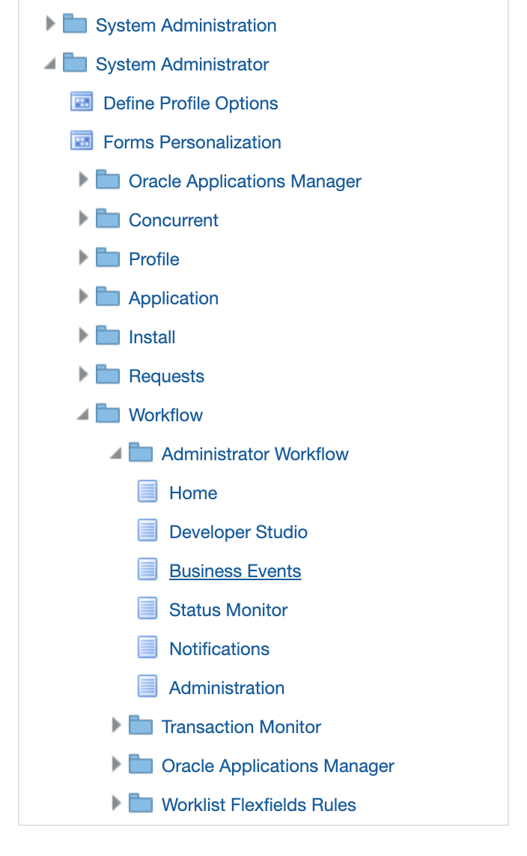

* The Business Events page looks like below. Click on the **Create Event** button to start creating an event

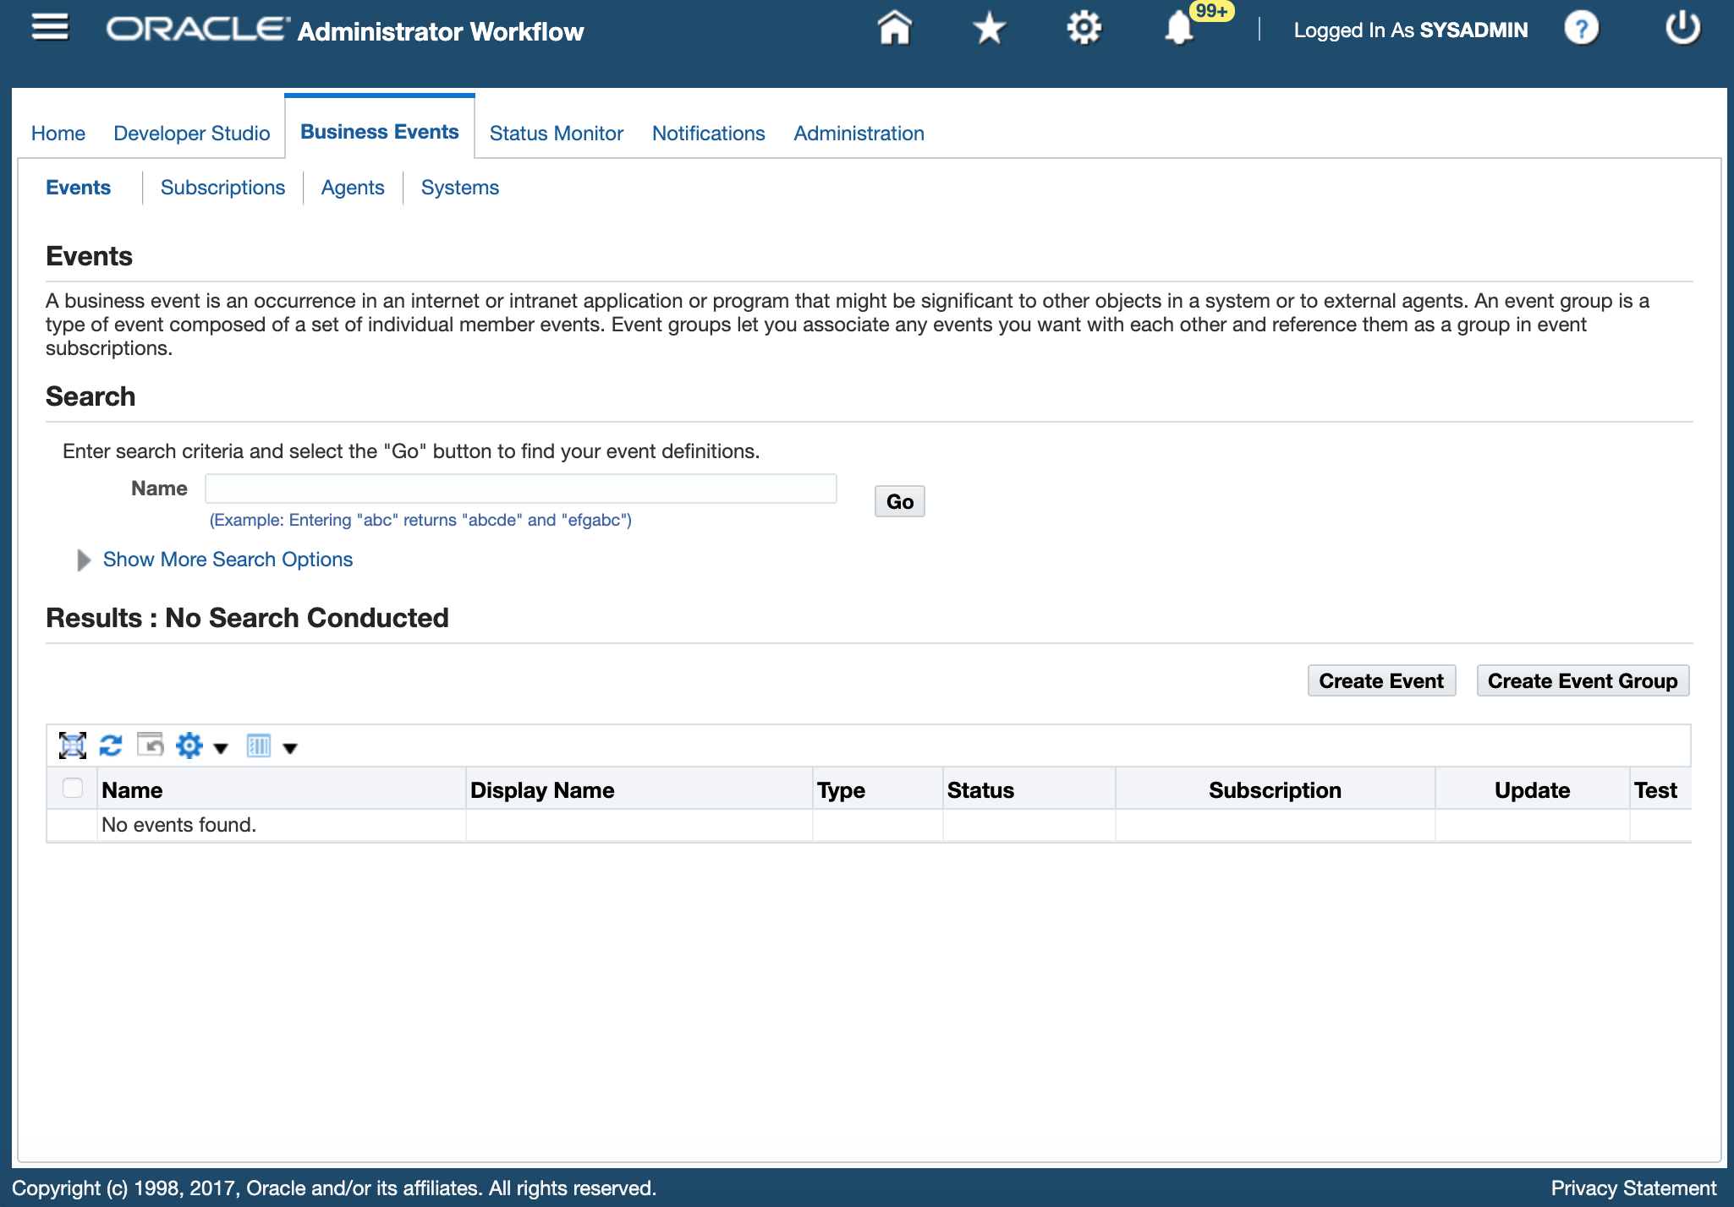

* The Create Business Event page loads. Enter information for Event Name, Display Name, Owner Name and Owner Tag details as follows:
  + Name: xx.oracle.apps.send.createpo
  + Display Name: Create PO custom event
  + Status: Enabled
  + Owner Name: Application Object Library

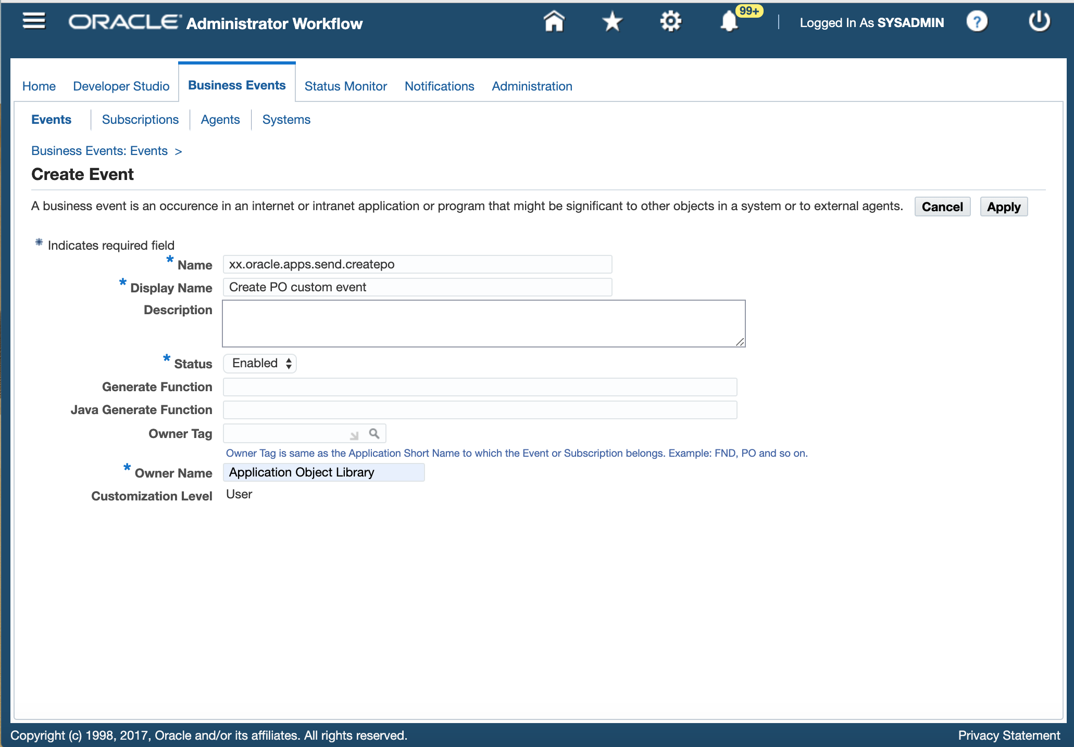

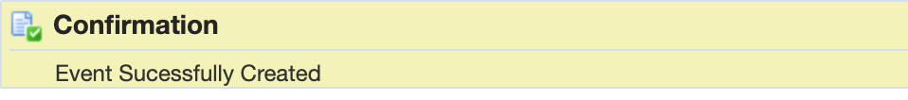

* Click on Apply button that shows success message:
* Click on Business Events tab to go back to the Business Events page. Type in the event name; xx.oracle.apps.send.createpo in the Search field and click on **Go** button.

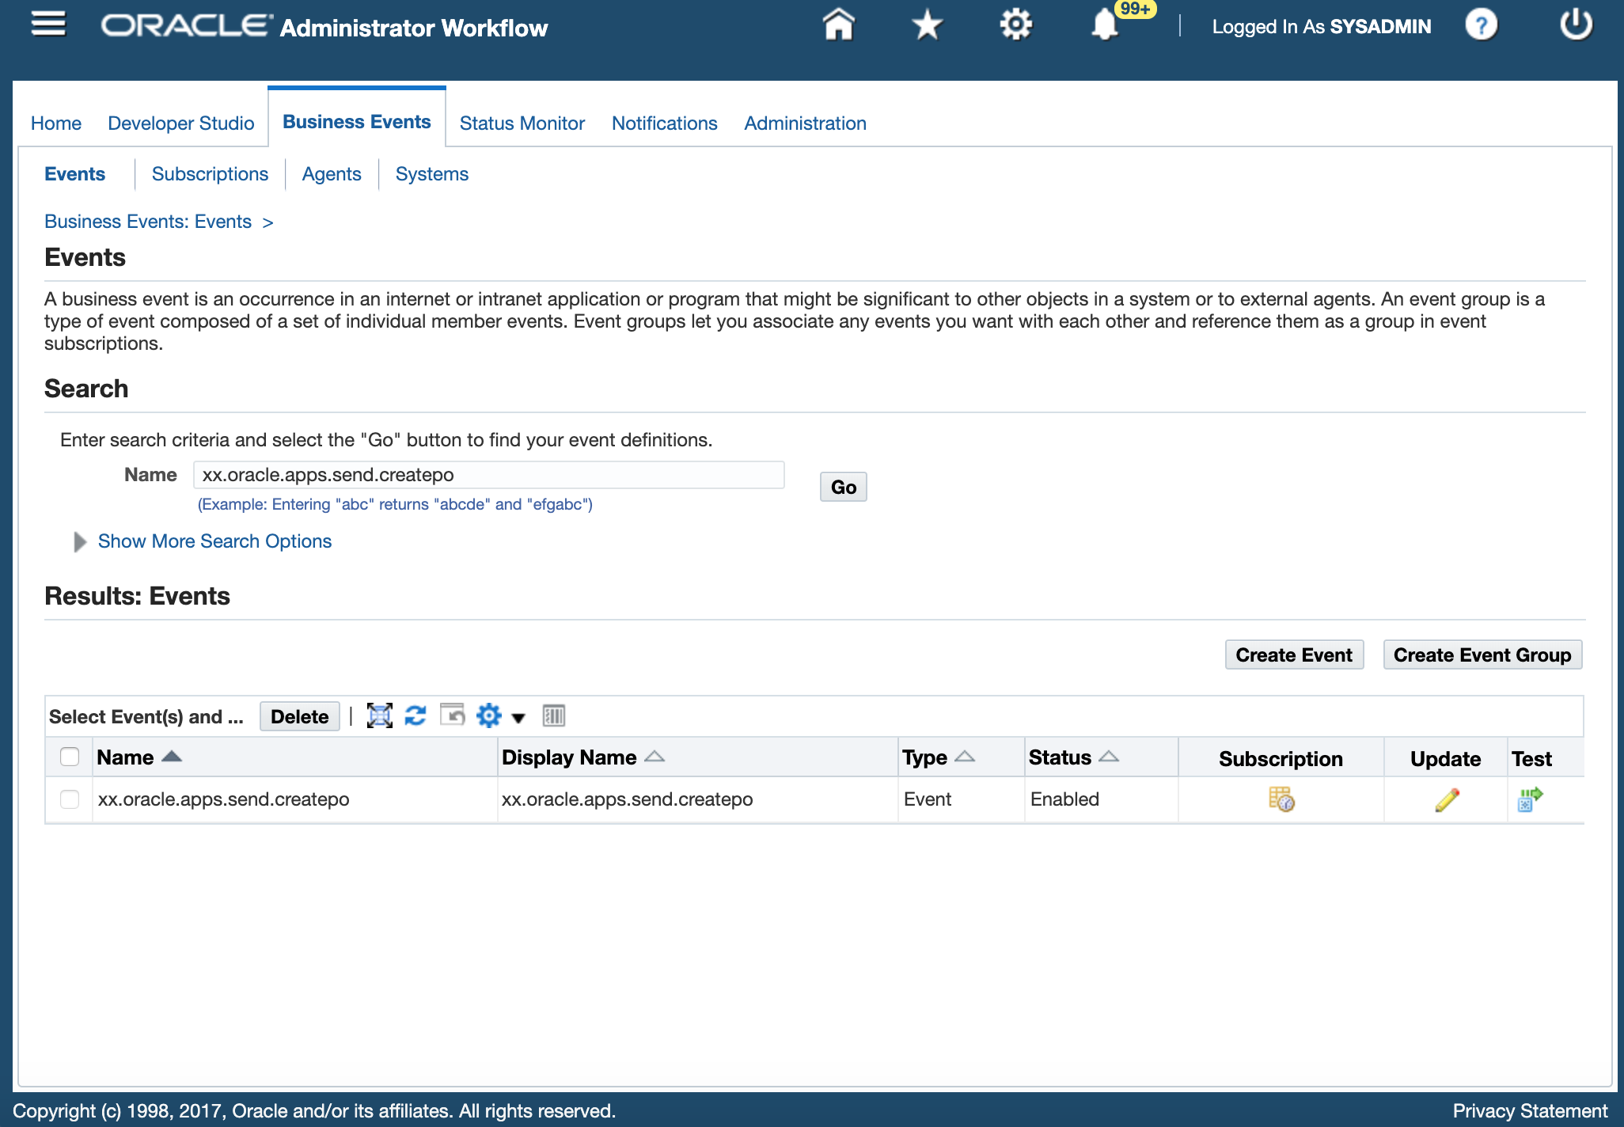

* In the Subscription screen, click on the **Create Subscription** button to create a subscription.

Macintosh HD:private:var:folders:b7:vkw3bqhd7z19frvkxrbb3rfr0000gn:T:TemporaryItems:Screen Shot 2019-08-15 at 2.38.11 AM.png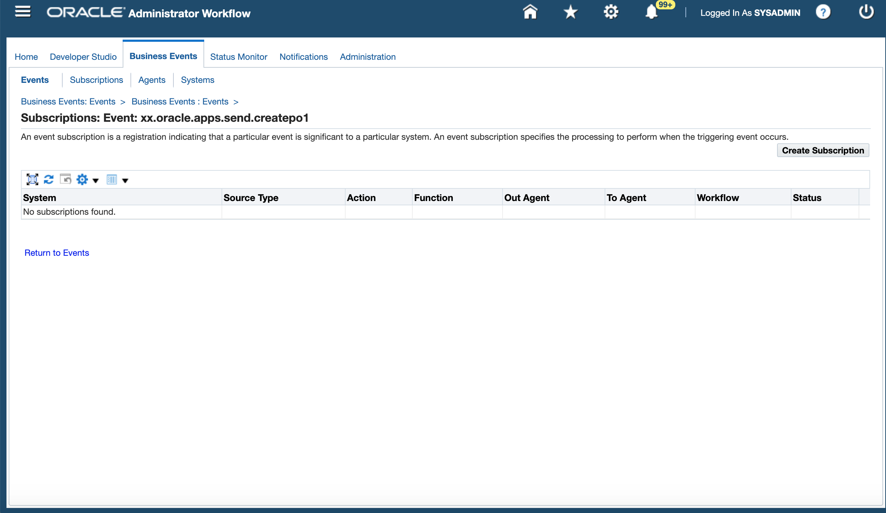

* Fill in the subscription details as shown in the screenshot below. Enter system node information and mentioned Action Type as "Custom". Click on the Next button:

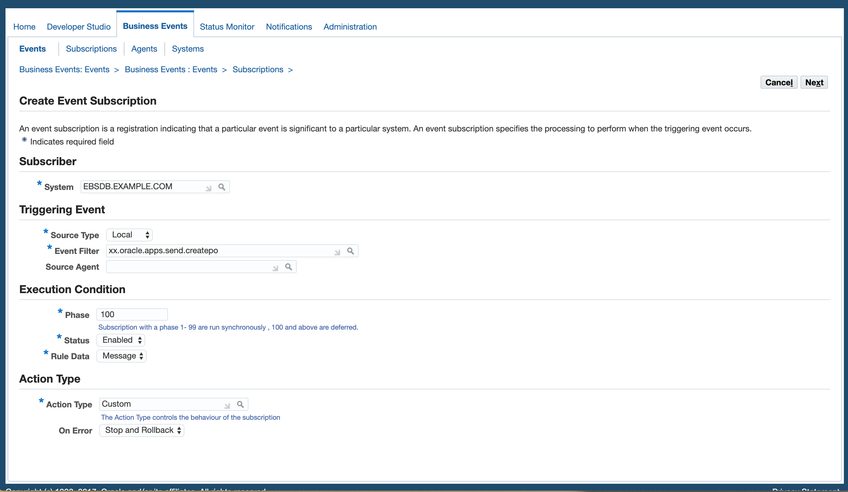

* In the Action section, type **xxcust_anyevent_log** for PL/SQL Rule Function. This function will be created as part of PL/SQL deployment and will serve as a temp location where fired event will be logged.
* Use **FND** for the Owner Tag, the Owner Name is automatically filled as **Application Object Library**.

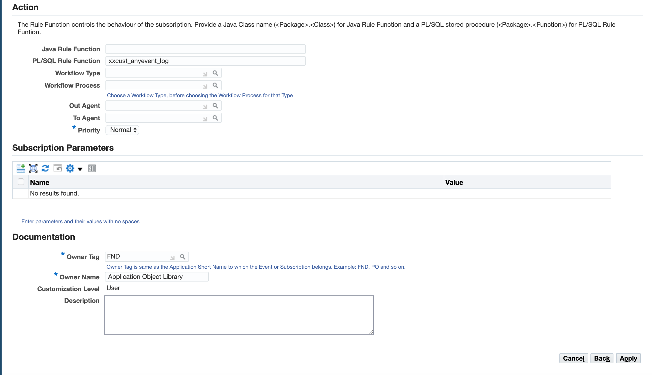

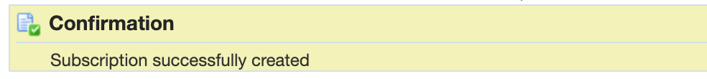

* Click on the Apply button. Success message will be shown:
* The subscriptions page shows the newly created subscription.

# Macintosh HD:private:var:folders:b7:vkw3bqhd7z19frvkxrbb3rfr0000gn:T:TemporaryItems:Screen Shot 2019-08-15 at 3.03.57 AM.png

## Deploy PL/SQL for the Event Trigger and Subscription Function

# Current State Workloads/Use Cases

This section needs to be updated with the workloads/use cases and OCI-C cloud services upon which they are running. Indicate is DEV/Test and/or Production as appropriate.

|  |  |  |
| --- | --- | --- |
| **Workload/Use Case** | **DEV/Test, PROD** | **OCI-C Cloud Services(s)** |
| Oracle E-Business Suite | DEV/Test, PROD | Compute, DBCS |
|  |  |  |
|  |  |  |
|  |  |  |

# Current State OCI-C Architecture

This section to be updated with Current State OCI-C Architecture diagram.

# Current State OCI-C Network Architecture

This section needs to be updated with Current State OCI-C Network Architecture diagram.

# OCI Bill of Material (BOM)

This section to be updated with OCI Bill of Material (BOM). Include non-Production, Production and DR if applicable.

**Production**

|  |  |  |  |  |  |  |  |  |  |  |
| --- | --- | --- | --- | --- | --- | --- | --- | --- | --- | --- |
| **Cloud Service** | **Type** | **Metric** | **SKU** | **Quantity** | **Duration in Months** | **List Price** | **Discount** | **Selling Price** | **Price/Month** | **Net Fee for 1 Year** |
| Oracle Cloud Infrastructure - Compute - VM Dense I/O - X7 - APPS TIER* | Monthly Commit | OCPU | B88516 | 20 | 12 | $ | 0% | $ | $ | $ |
| Oracle Cloud Infrastructure - Database Exadata Quarter Rack - X6 – BYOL | Monthly Commit | NA | B88856 | 1 | 12 | $ | 0% | $ | $ | $ |
| Oracle Cloud Infrastructure - Object Storage - Storage | Monthly Commit | GB | B88324 | 20480 | 12 | $ | 0% | $ | $ | $ |
| Oracle Cloud Infrastructure - Object Storage - Requests | Monthly Commit | Requests | B88323 | 10,000 | 12 | $ | 0% | $ | $ | $ |
| Oracle Cloud Infrastructure - Block Volume | Monthly Commit | GB | B88322 | 2048 | 12 | $ | 0% | $ | $ | $ |
| Oracle Cloud Infrastructure - FastConnect 1 Gbps | Monthly Commit | 1 Gbps | B88325 | 1 | 12 | $ | 0% | $ | $ | $ |
| Oracle Cloud Infrastructure - 100 Mbps Load Balancer | Monthly Commit | NA | B88319 | 1 | 12 | $ | 0% | $ | $ | $ |
| Total |  |  |  |  |  |  |  |  |  |  |

**Non-Production**

|  |  |  |  |  |  |  |  |  |  |  |
| --- | --- | --- | --- | --- | --- | --- | --- | --- | --- | --- |
| **Cloud Service** | **Type** | **Metric** | **SKU** | **Quantity** | **Duration in Months** | **List Price** | **Discount** | **Selling Price** | **Price/Month** | **Net Fee for 1 Year** |
| Oracle Cloud Infrastructure - Compute - VM Dense I/O - X7 - APPS TIER* | Monthly Commit | OCPU | B88516 | 20 | 12 | $ | 0% | $ | $ | $ |
| Oracle Cloud Infrastructure - Database Exadata Quarter Rack - X6 – BYOL | Monthly Commit | NA | B88856 | 1 | 12 | $ | 0% | $ | $ | $ |
| Oracle Cloud Infrastructure - Object Storage - Storage | Monthly Commit | GB | B88324 | 20480 | 12 | $ | 0% | $ | $ | $ |
| Oracle Cloud Infrastructure - Object Storage - Requests | Monthly Commit | Requests | B88323 | 10,000 | 12 | $ | 0% | $ | $ | $ |
| Oracle Cloud Infrastructure - Block Volume | Monthly Commit | GB | B88322 | 2048 | 12 | $ | 0% | $ | $ | $ |
| Oracle Cloud Infrastructure - FastConnect 1 Gbps | Monthly Commit | 1 Gbps | B88325 | 1 | 12 | $ | 0% | $ | $ | $ |
| Oracle Cloud Infrastructure - 100 Mbps Load Balancer | Monthly Commit | NA | B88319 | 1 | 12 | $ | 0% | $ | $ | $ |
| Total |  |  |  |  |  |  |  |  |  |  |

# OCI Solution Architecture

This section needs to be updated with OCI Solution Architecture (below are examples)

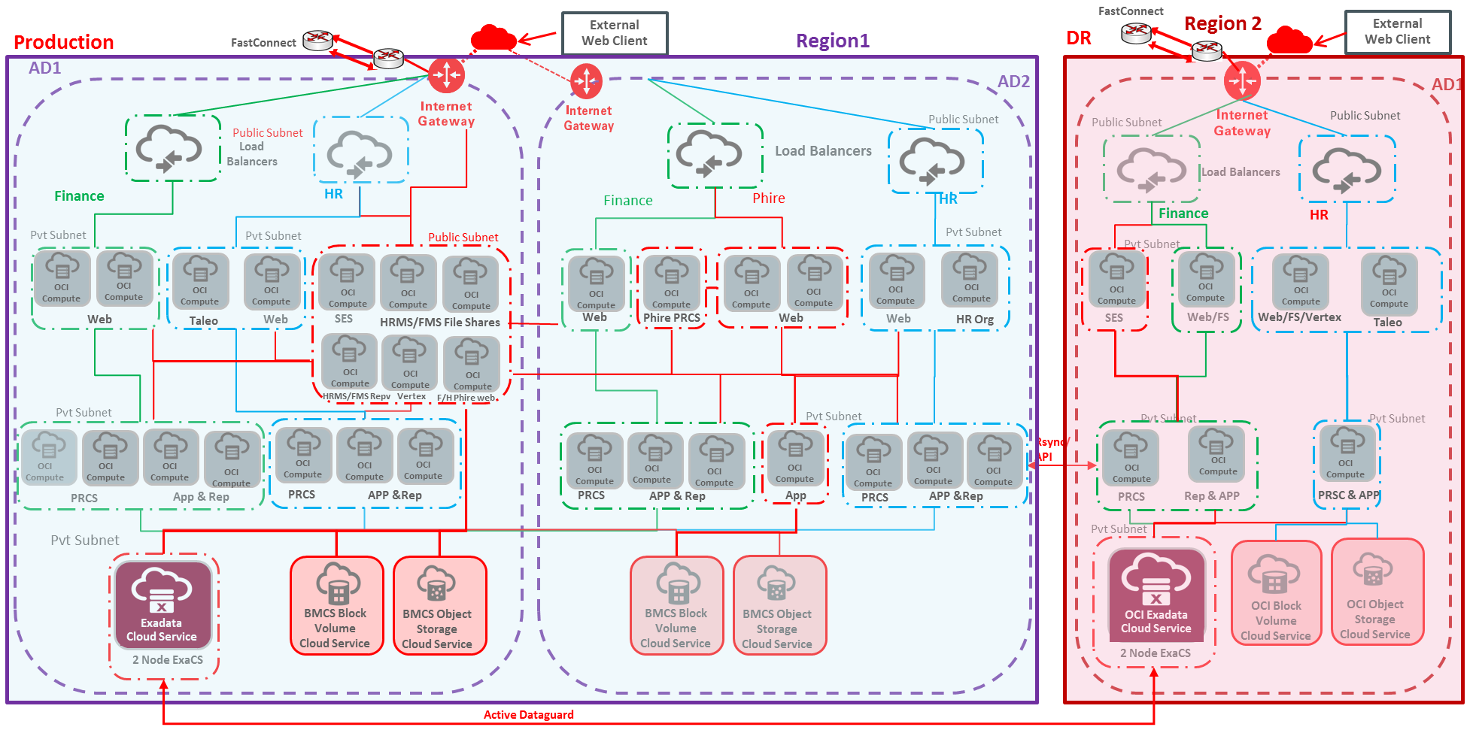

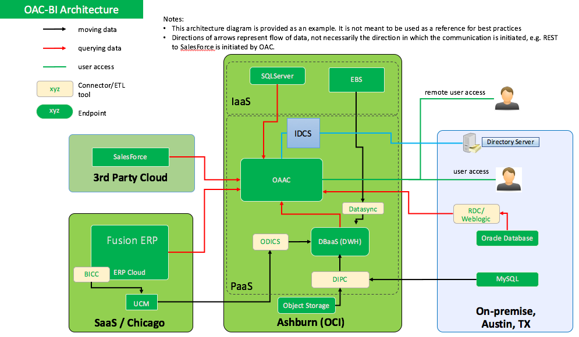

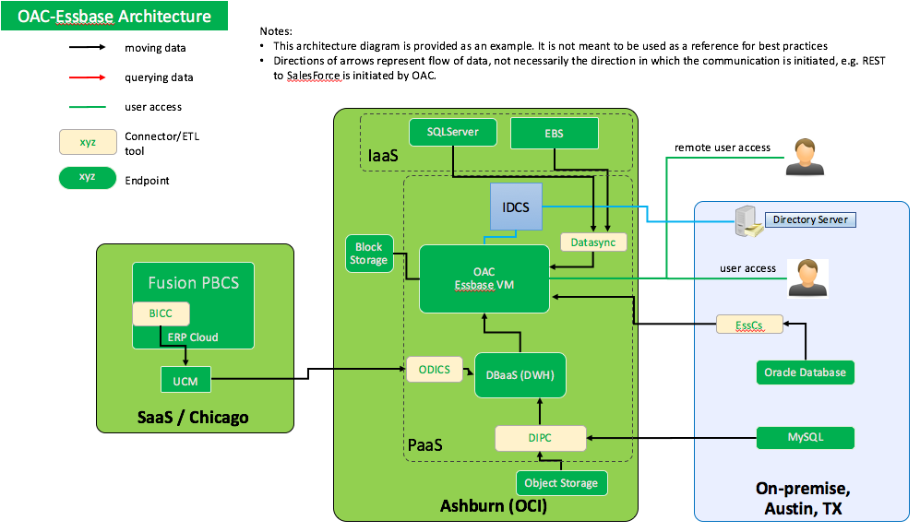

# OCI Network Architecture

This section needs to be updated with OCI Network Architecture.